EXP 19. Demonstrate Infrastructure as a Service (IaaS) by creating a Virtual Machine using a Public Cloud Service Provider (Azure), configure with required memory and CPU.

AIM:
To demonstrate infrastructure as a service (iaas) by creating a virtual machine using a public cloud service provider (azure), configure with required memory and cpu.

PROCEDURE:
STEP1: CREATE AN ACCOUNT IN MICROSOFT AZURE.
STEP2: GOTO RESOURCE GROUPAND CREATE A RESOURCE GROUP. STEP3: GIVE NECESSARY THINGS FOR RESOURCE GROUP.
STEP4: CREATE AVIRTUAL NETWORK FOR TO CREATE AVIRTUALMACHINE .
STEP5: NOW CREATE A VIRTUAL MACHINE WITH UR IPADDRESS ANUSERNAME AND PASSWORD FOR YOUR VIRTUAL MACINE.
STEP6: AND YOUR VIRTUAL MACHINE IS DEPLOYED.
STEP7: NOW CONNECT THE VIRTUAL MACHINE AND DOWNLOAD THE RDP FILETO OPEN YOUR
WINDOWS VIRTUAL MACHINE.
STEP8: NOW RESIZE THE VIRTUAL MACHINE SIZE.
STEP9: CREATED ANEW WINDOWS VIRTUAL MACHINE

IMPLEMENTATION:
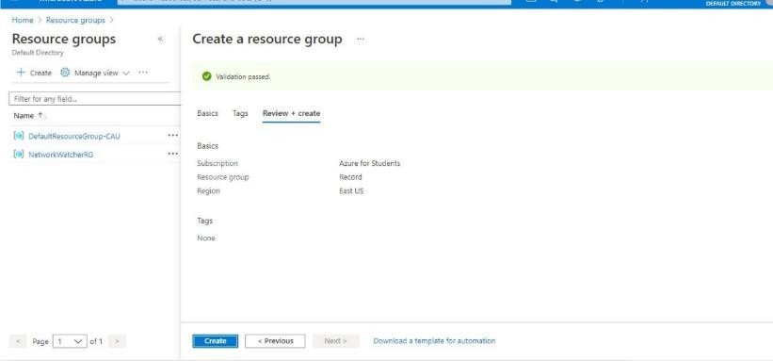

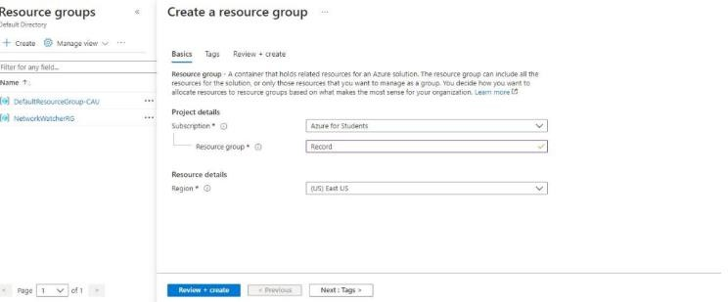

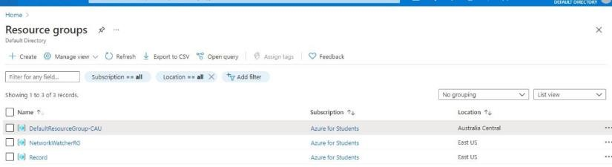

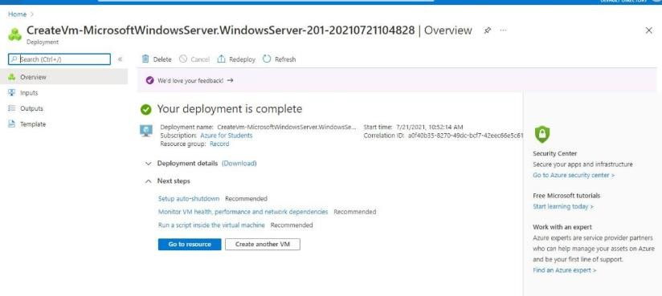

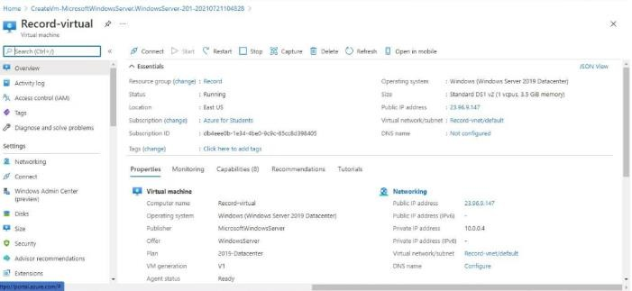

RESULT:
Infrastructure as a service (iaas) by creating a virtual machine using a
public cloud service provider (azure), configure with required memory and cpu has been demonstrated.

